In this lesson we will talk about the View, Text and Button
These are the basic and fundamental things in React according to UI
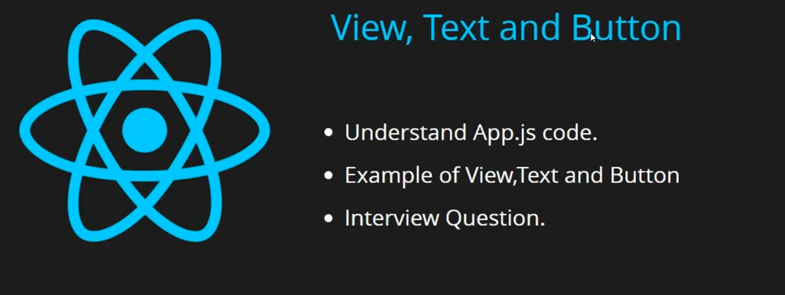
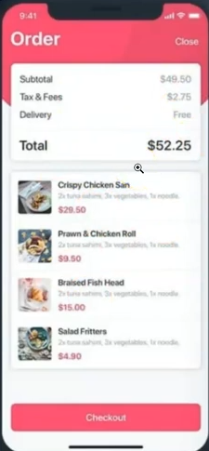
You can see in above screen that are text, images and button
aand with the help oif these you can see your UI
Here we are talking about View, text and button . There are other things that make UI that are inputboxes , checkbox , radiobuttons, images
By adding style you can decrease or increase the size you can di many things
If you will learn Text , View and Button then you will learn all other things automatically.
You will not get any other problem
and these are ver eas to implement and unerstand
Why i am teaching you this first but not advanced thing like props ,states, component , jsx
because when we learn something new then we need to know is our output coming or not
are mwe able to create somthing or not and these are UI things whn yoiu apply it then you will see the output immediately and the chances of occurance of errors are very less
Through this you get the confidence and your desire to learn more will increase and you will feel good tht you have produces something that;s hy we are going step by step
In this lesson we will understand App.js code and what is written inside this and wht is theor meaning and then we will see here example of View, Text and Button from scratch amd then we will discuss interview question
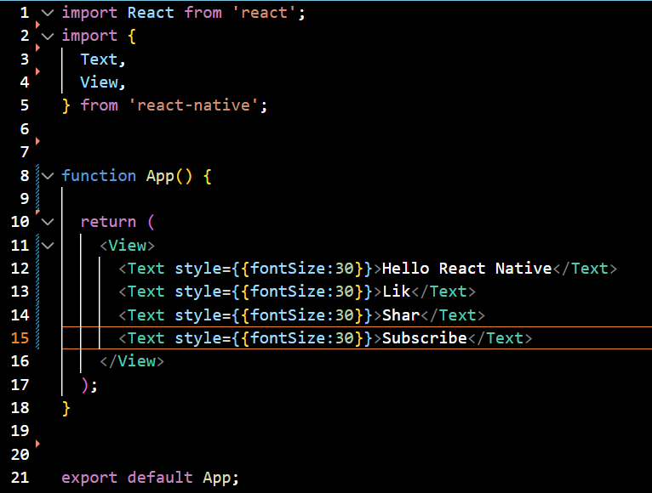
So first we imported React because we know react native internally use React js
So in code rendered and in code compiler react js is used (who knows)
and then in line 2,3,4 and 5 we have imported Text, View from react-n maybe to convert the code to native javascript
Like in HTML we have body tag, font, div tag similarly this text an dview are a part of React Native and we don't call it tags we call it components
We will make user defined components we will make next lessons to tell how to make
them . For now just understand that we don't call them tags neither elements but components neither we call it elements
So we imported View and text component from react-native package .later we make function named as App and then we return the view, text component as shown above
Like in html we have two tags thai is opening tag and closing tag similarly we have in react Native
and after defining the function we export the App component
When this App got exported then what was made of this it goes to index.js
In index.js
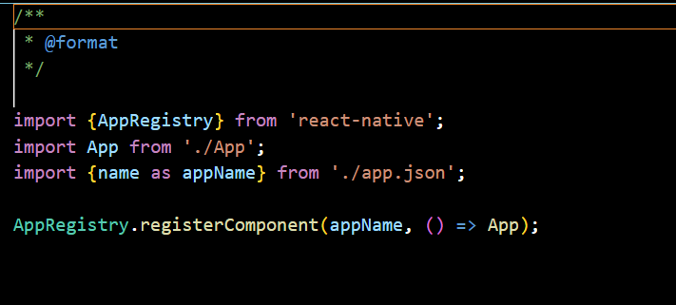
you can see we are importing app in our index.js
and we are registering the app component here by registerCompoonent
Because whatever code we write is treated as component
(maybe we are app as a component by registering it in index.js)
so our app.js has become a component and it will be registered here
It got registered and you can see the output in your emulator
For now our focus is not on this but on View , Text component

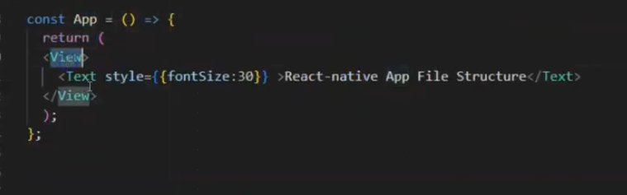
If we remove View then thre will be no error
In previou times it used to happen that you should have a view as the parent tag
otherwise you could not write text here
View was kind of Body or div tag
and you can call Text component as label

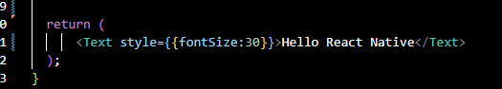
Now we remove the View component themn the output remains the same and no error was shown

We remove the Text compoennt and all the import cammand

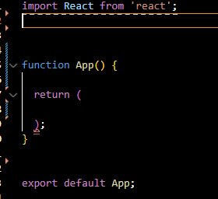
Now we start from starand import somethig from React native
In html when we used tag we did not need to import it because it is already defined and is supported by Browser
But there are react native thing so we need to import it from our react native or other package
So we import Text component from react native

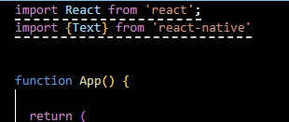
Whatever component we imported first lettter should be capital but in html it was used to small letter
Now we write Text compoennt in retiurn of App function
Now our output is shown below

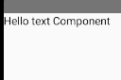
but it is very small in size
we will increase its style by applying inline CSS by using style attribute We will no go to its detail

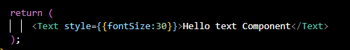
Now our output will look like below

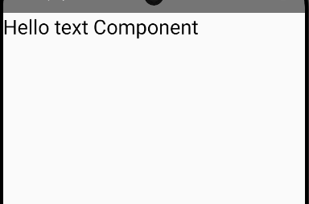
you don't need to write px in size it will automatically set it to that pixel(maybe) size
So it is a normaal text now
We will explore more things but this is ther basic things
Suppose you copy your text component
and then paste it below it like below

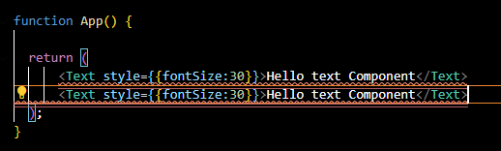
and when you save it then in
emulator error will be shown like below

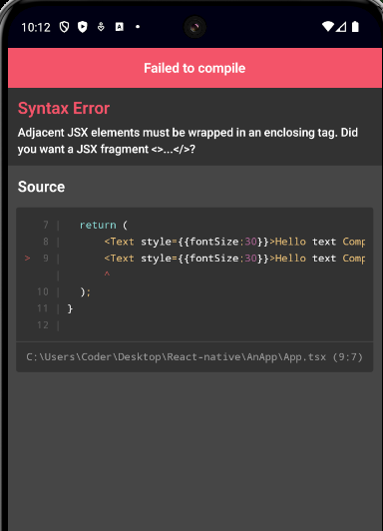
th error is basically saying that we cannot use write component like this

It is basically saying that the component will always return a single component not two component simultaneously so mwe wrap all other component inside a component so that technically we will return a single component in retrun
So that's why View is used it act as wrapper for other components in return so no error will be shown

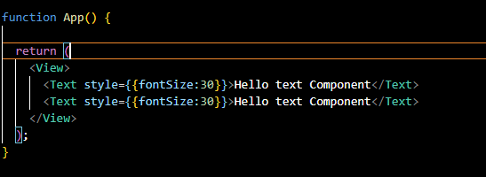
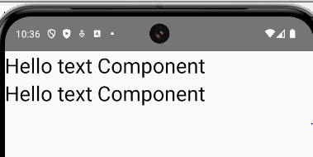
Now we make the second text smaller and make the third text and make it smaller than Second Text smaller

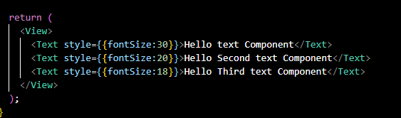

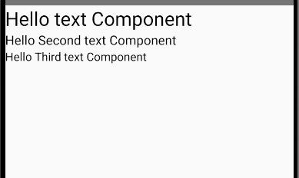
In interview it is often asked that can you write text inside View component like this
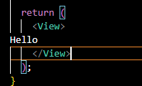
then we will get the error in emulator

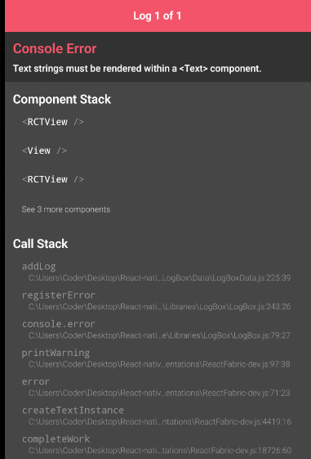
It is because View is just a wrapper and the abive error is saying that all teh text will go inside Text compoonent
It is not just that View is the only component that can act as a wrpper in the upcoming lessons

Now suppose need a button
First from that import Button as well from react-native as shown below

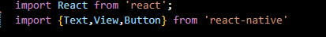
and use this camponent in return of the component
Now what will the button will contain will be decided by the title attribute it will not happen like it used to happen in text component All the text that will come in title attribute of button component

Note:-
You can format your document in the VS Code by Shift+Alt +F
If you are doing it first time then it will aask you the formatter and you can choose from the similar list shown below . We choose the prettire fromatter(I don't know)
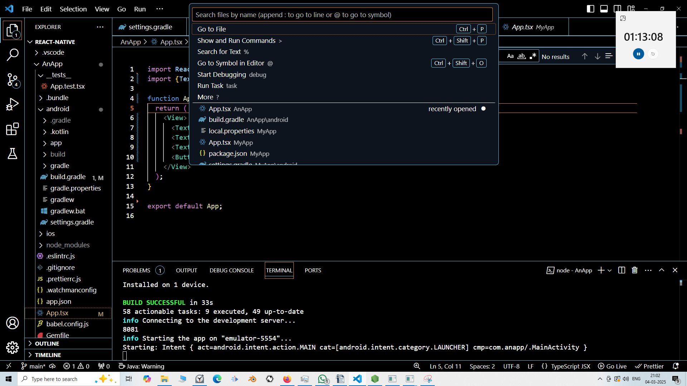
Now we type the Press here as a value in title attribute
because in Phones we don't click we tap

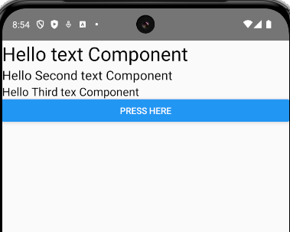
click will happen in softwares and desktop not on mobile

you can also do below

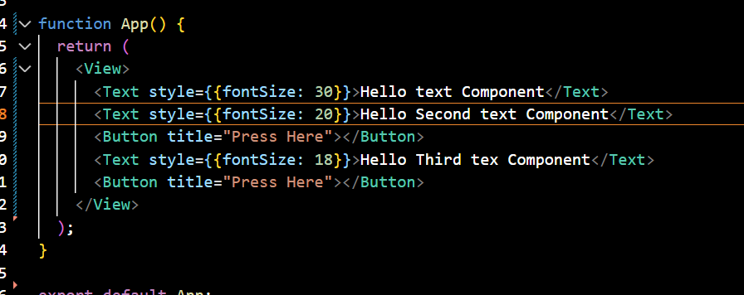
Output

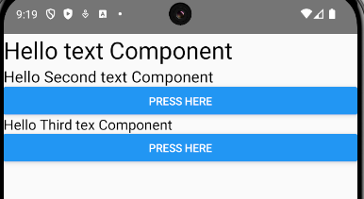
Interview question

Can we use text between the View tag
No you cannot use text between tags
the basis component between which the multiple element occurs is the view element

What is the difference between Component and a tag

The tag always starts with small letters( no necessary ) and component always starts with capital letters whether you think about react native or react js

Now that's all for this lesson. In next part we are
All right tharts all for this part in next lesson we will start jsx

